Works Cited: Basic rules
- Begin your Works Cited page on a separate page at the end of your research paper. It should have the same one-inch margins and last name, page number header as the rest of your paper.
- Label the page Works Cited (do not italicize the words Works Cited or put them in quotation marks) and center the words Works Cited at the top of the page.
- Double space all citations, but do not skip spaces between entries.
- ***** Indent the second and subsequent lines of citations by 0.5 inches to create a hanging indent.
- List page numbers of sources efficiently, when needed. If you refer to a journal article that appeared on pages 225 through 250, list the page numbers on your Works Cited page as 225-50. Note that MLA style uses a hyphen in a span of pages.
- Put page in alphabetical order.
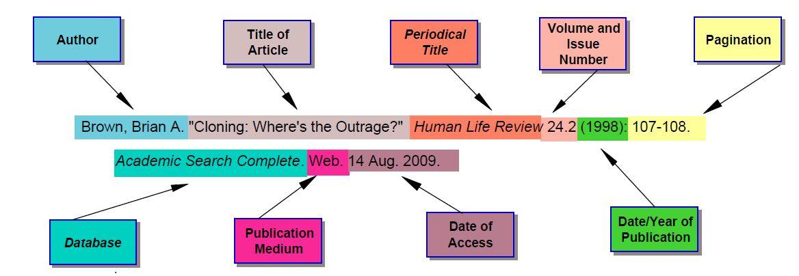

Indent 0.5 inches
see next page for full example
Works Cited
Guerard, Albert J. “The Women of the Novels.” Hardy. Ed. Albert J. Guerard. Englewood Cliffs, NJ: Prentice-Hall, 1963. 63-70.
Gurko, Leo. “Love in Far from the Madding Crowd.” Twentieth Century Interpretations of Far from the Madding Crowd. (1985): 17-25. Gale. Web. 1 Oct. 2009.
Hardy, Thomas. Far from the Madding Crowd. New York: Penguin, 1960.
May, Charles E. “Thomas Hardy.” Critical Survey of Long Fiction. Ed. Frank N. Magill. Vol. 4. Pasadena: Salem, 1991.
Scott-James, R. A., and C. Day Lewis. “Thomas Hardy.” British Writers. Ed. Ian Scott-Kilvert. Vol. 6. New York: Scribner, 1983.

